TASK 1: ERROR IN OUTPUT

The test Integer that has been supplied exceeds from the range of int as integer can store values from -32,768 to 32,767.

TASK 2 : Swapping Values
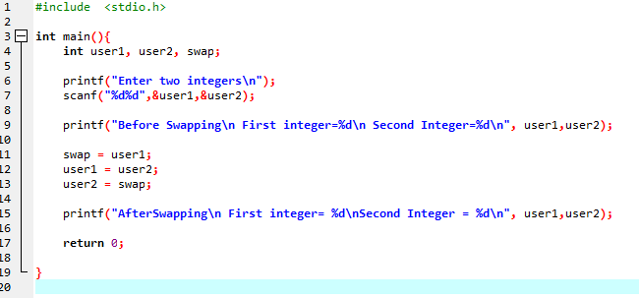
CONSOLE:
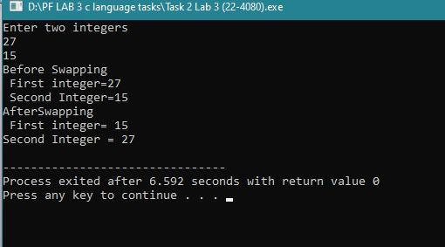

TASK 3 : Salary and Tax Rate
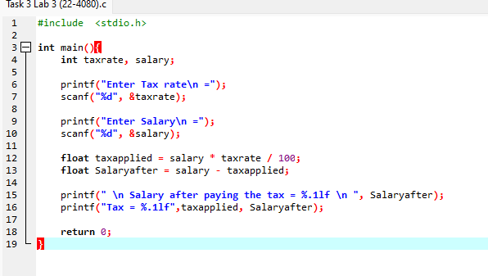
CONSOLE:
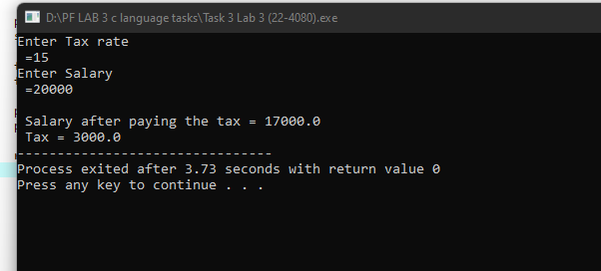

TASK 4: FUEL COST
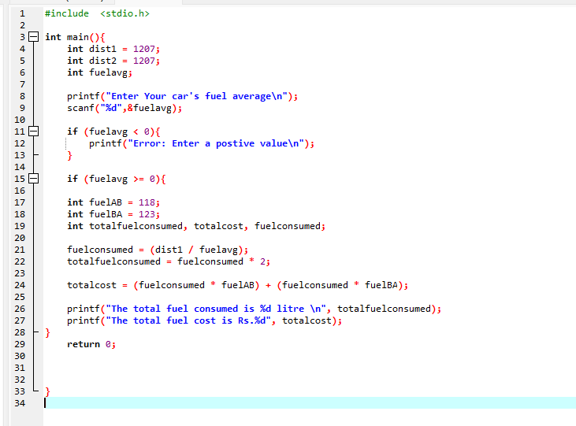
CONSOLE:
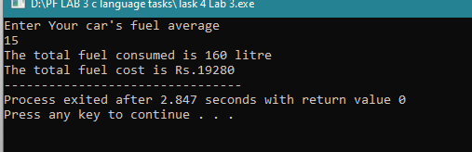
RESTRICTION CHECK IN TASK 4: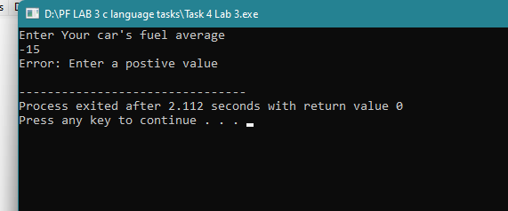
TASK 5 : (SIMPLE INTEREST)
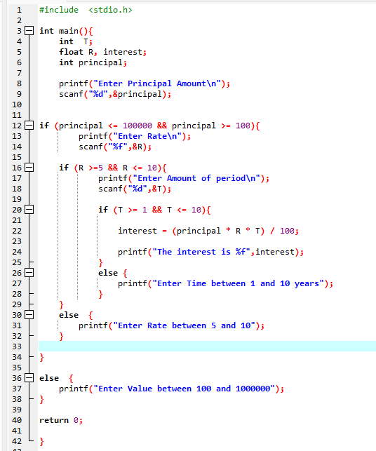
CONSOLE OUTPUT:
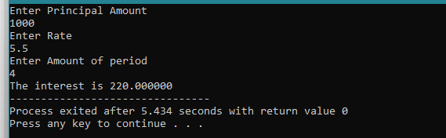
CONDITION CHECKS IN TASK 5:
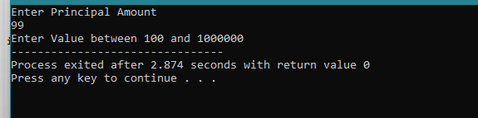
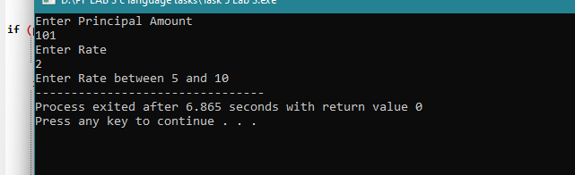
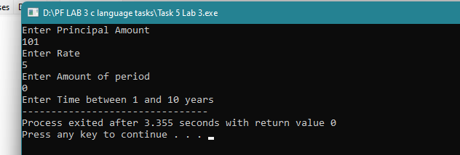

TASK 6: (gradient)
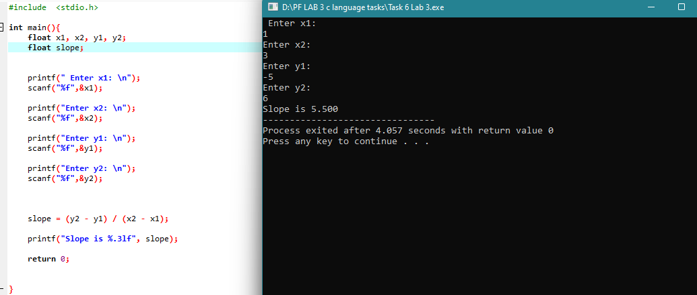

TASK 7: (BONUS - SHAPES)
a)
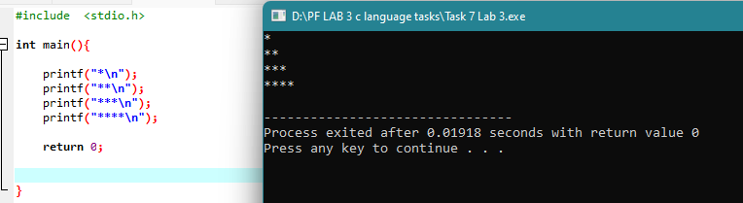

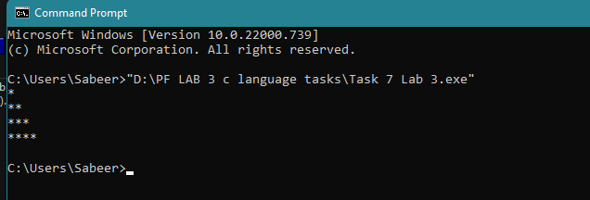
b)
